The dataset **opl_female.csv** contains data on female finishers of the Lake Placid Ironman Triathlon from 2002 to 2022. An ironman triathlon is comprised of 3 events. The motivation for this data analysis is to explore the relationship between bike and run times (in minutes) in order to gain insights into the performance patterns of the athletes. For this activity, we will specifically focus on times from 2022 Canadian Finishers.

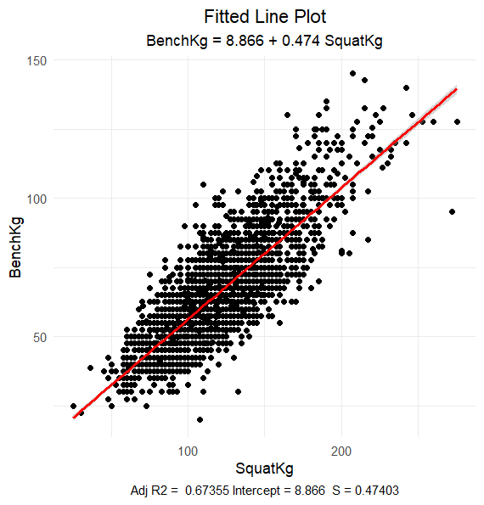

1. What is the explanatory variable in this situation? What is the response variable? What type are both variables? What are the units?

Explanatory Variable: Squat Weight - Kilograms  
Response: Bench Weight - Kilograms  
**Both variables are Numerical**

1. What does each point in the scatterplot represent?

Each dot represents a 25-year-old female competitor.

1. Report the least squares regression equation for predicting run time from bike time.
$$\hat{BenchKg}= 8.866+0.474(SquatKg)$$

2. Suppose that you were interested in using this regression model to predict the Bench weight for other age ranges within female competitors. What assumption about your data would you need to make?

You need to assume that the relationship between squat weight and bench weight is the same for all ages as it is for 25-year-old women (which is what the regression model is based on).

1. Sara Crews had a 120.0 squat weight. What is her predicted bench weight? Regardless of your answer to the previous question, continue to use the equation from question 3.

$$\hat{BenchKg}= 8.866+0.474(120.0)=65.746 minutes$$

1. Crews’ bench weight was 65.00 kilograms. How far off was the model prediction? Explain why we might see this observation.

65.0 Kg – 65.746 Kg = -0.746 Kg.  
Answers may vary for the explanation.

1. Interpret the slope of the model in the context of the application. Be sure to be mindful of the units.

For every 1 kilogram of weight for Squat, the Bench weight is expected to increase by 0.474 kilograms

1. Interpret the intercept of the model in the context of the application.

When the Squat weight is zero, the expected Bench weight is 8.866 kilograms.

1. Is the intercept interpretation meaningful? Explain.

It is meaningful because if the squat weight is 0 Kg, then it makes sense that the bench weight is very low.

1. What percent of variation in Squat weight is explained by the model using Bench weight? What is the sample correlation?

R2 = 67.4%

1. Based on your comprehensive analysis, describe the relationship between bench weights and squat weights using multiple pieces of information from your findings.

Solutions may vary, but, a solution should incorporate a description of the scatterplot supplemented with the results from the regression model. This relationship seems linear and fairly strong (resulting in an R-Squared of 67.4%).